MINDSTORMS EV3

SWITCH

This is the basic Switch (if, else statement).

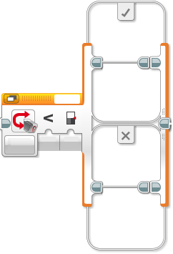

## For Switch use with Sensor’s, see sensor’s page

There are 3 main parts of this block:

1. Condition
2. True
3. False



# True

The blocks you put in here will be done when the condition is TRUE.

# False

The blocks you put in here will be done when the condition is FALSE.

# Condition



This is the most complex part. The Condition can be in different “Modes” and we’ll discuss them all. This is the Mode button

(For Modes using sensors, please go to the corresponding sensor page)

# Mode – Numeric

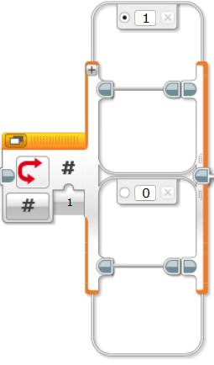

When Input

Is “1” the top box will run

The dot next to the 1 means if input is neither 1 nor 0,

Then this box will run.

You can change this dot

To any box.

You can add more box’s to include more options such as “2” and “3”.

You do this by pressing the +

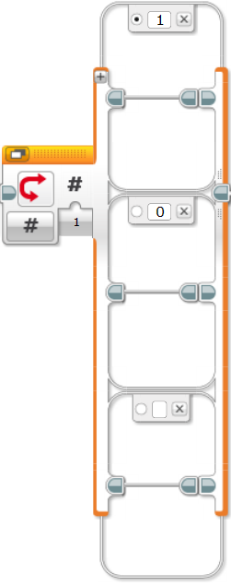

Now you can type a new number here

You can delete a block here

# Numeric (Advanced)

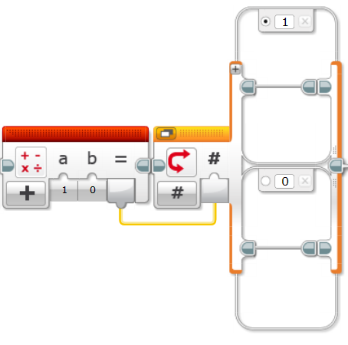Numeric mode will usually be used with

Math Block (See Math Block for more information)

The Math Block equals

1+0

The output yellow WIRE puts the

answer in the input of the switch.

For this 1 + 0 = 1 and

the top block will run

# Mode – Logic

Input = True

Top block will run

Input = False

Bottom block will run

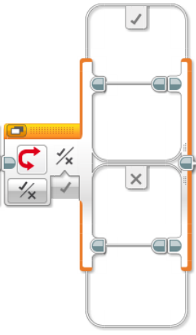

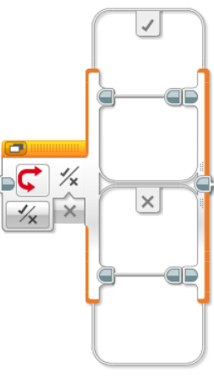

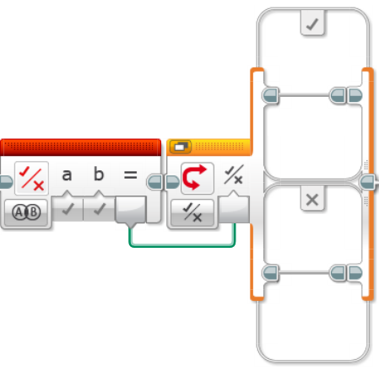

# Logic (Advanced)

Using the logic block, you can perform logical decisions

within your programs.

Example 1:

A = True

B = True

Therefore A AND B = True

Top block will run

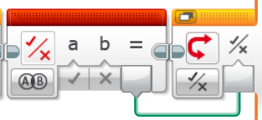Example 2:

A = True, B = False

Therefor A AND B = False, Bottom block will run

# Mode – Text

Input = a

Top block will run

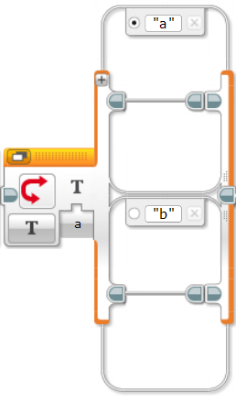

Input = b

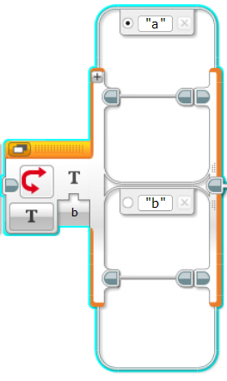Bottom block will run